…………………………………………………………………………………………………..

**SSCBS**

**MAYANK CHOPRA**

**ROLLNO -23719**

**7) Identification & Authentication Failure**

**Description –**

Identification and authentication failure is the lack of security present inside the code by which attacker can easily use the false credential and get logged into the account of any user. Sometimes attacker can bypass two factor authentication by using the existing credentials.

The techniques used by attacker for this attack are –

Brute force, Session Hijacking, Social media attack squatting

**Impact-**

By this attacker can take over the accounts.

**Preventions-**

There should be strong passwords policies.

Limit/Increase delays login attempts.

**Reference –**

**POC –**

Step1) open the website put the dummy credential -> wiener:peter-> code will be step on email -> write the code , click on OK -> you will enter in your account

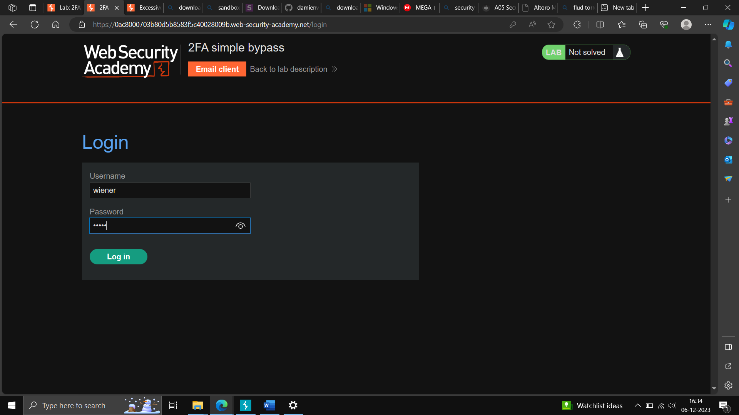

Step2)- logout the previous account, click on my account -> put another credential, email will be sent, go on URL -> remove login from URL and write my account and then enter.

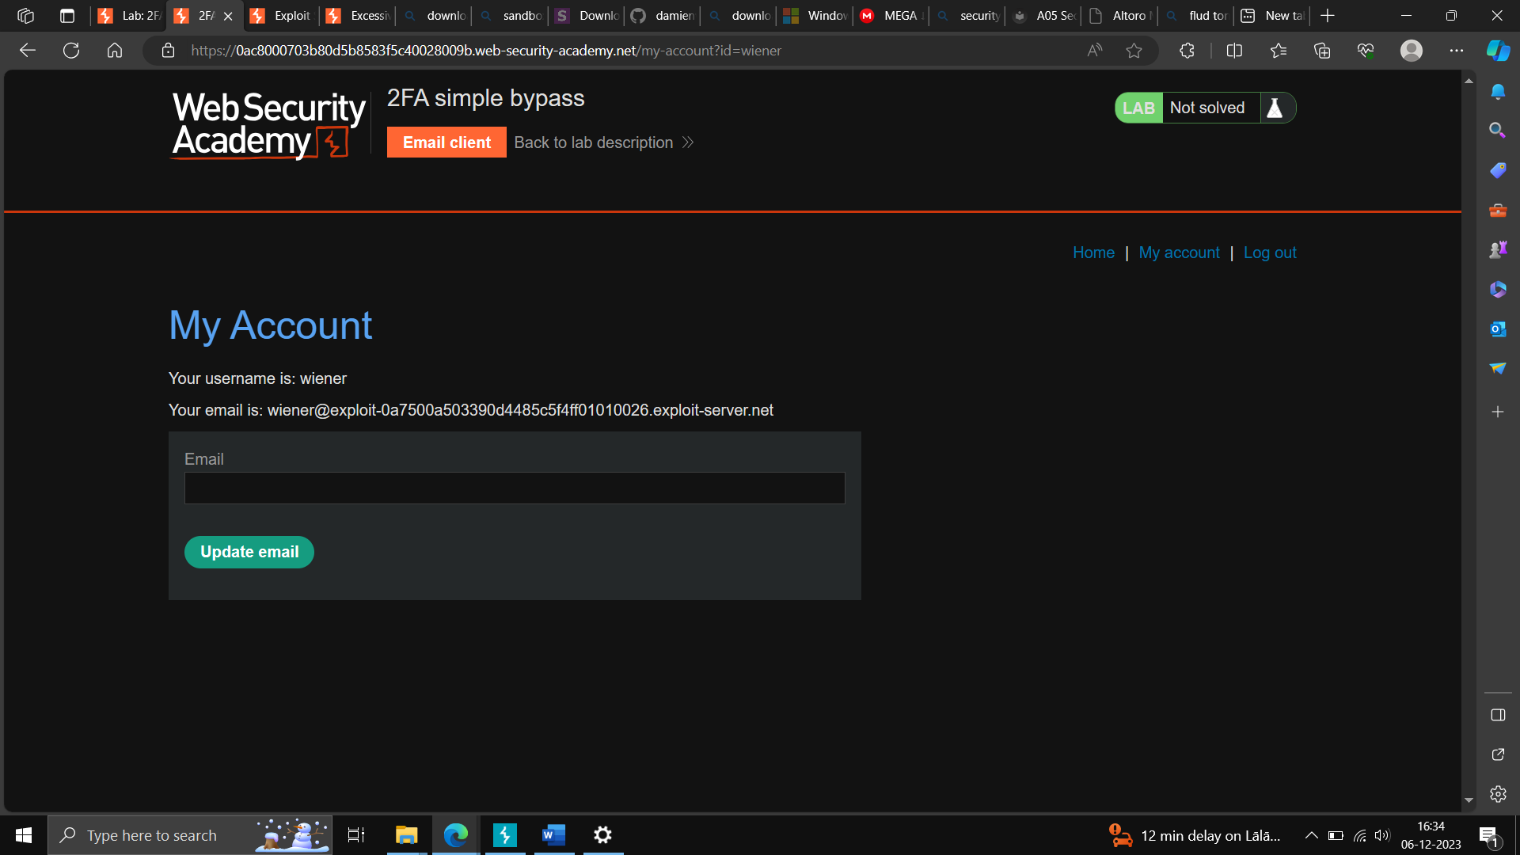

Step3)- lab is solved

